SIMATS ENGINEERING (SAVEETHA SCHOOL OF ENGINEERING)
Course Code & Title: | ECA5604 -5G/6G COMMUNICATION | Course Faculty: | Dr.K.Sathish
Student Name: | Velamuri Bhanodhay | Reg. No.: | 192412330
Dept / Batch: | BE.ECE / 2024 | Date: | 19/8/2026
Lab Observation

Experiment 12 :NB-IoT vs LTE-M Throughput Simulation

Objective 1: To evaluate and compare the Throughput (Mbps) performance of NB-IoT and LTE-M
under varying network conditions.

Matlab Code:

clc;clear;close all
S=0:5:30;
N=.05*(1-exp(-S/8)); L=1.2*(1-exp(-S/8));
disp('SNR NB-IoT(Mbps) LTE-M(Mbps)'),disp([S' N' L'])
subplot(211)
plot(S,N,'-o','LineWidth',2);grid on
title('NB-IoT Throughput vs SNR'),xlabel('SNR (dB)'),ylabel('Throughput (Mbps)')
subplot(212)
plot(S,L,'-s','LineWidth',2);grid on
title('LTE-M Throughput vs SNR'),xlabel('SNR (dB)'),ylabel('Throughput (Mbps)')

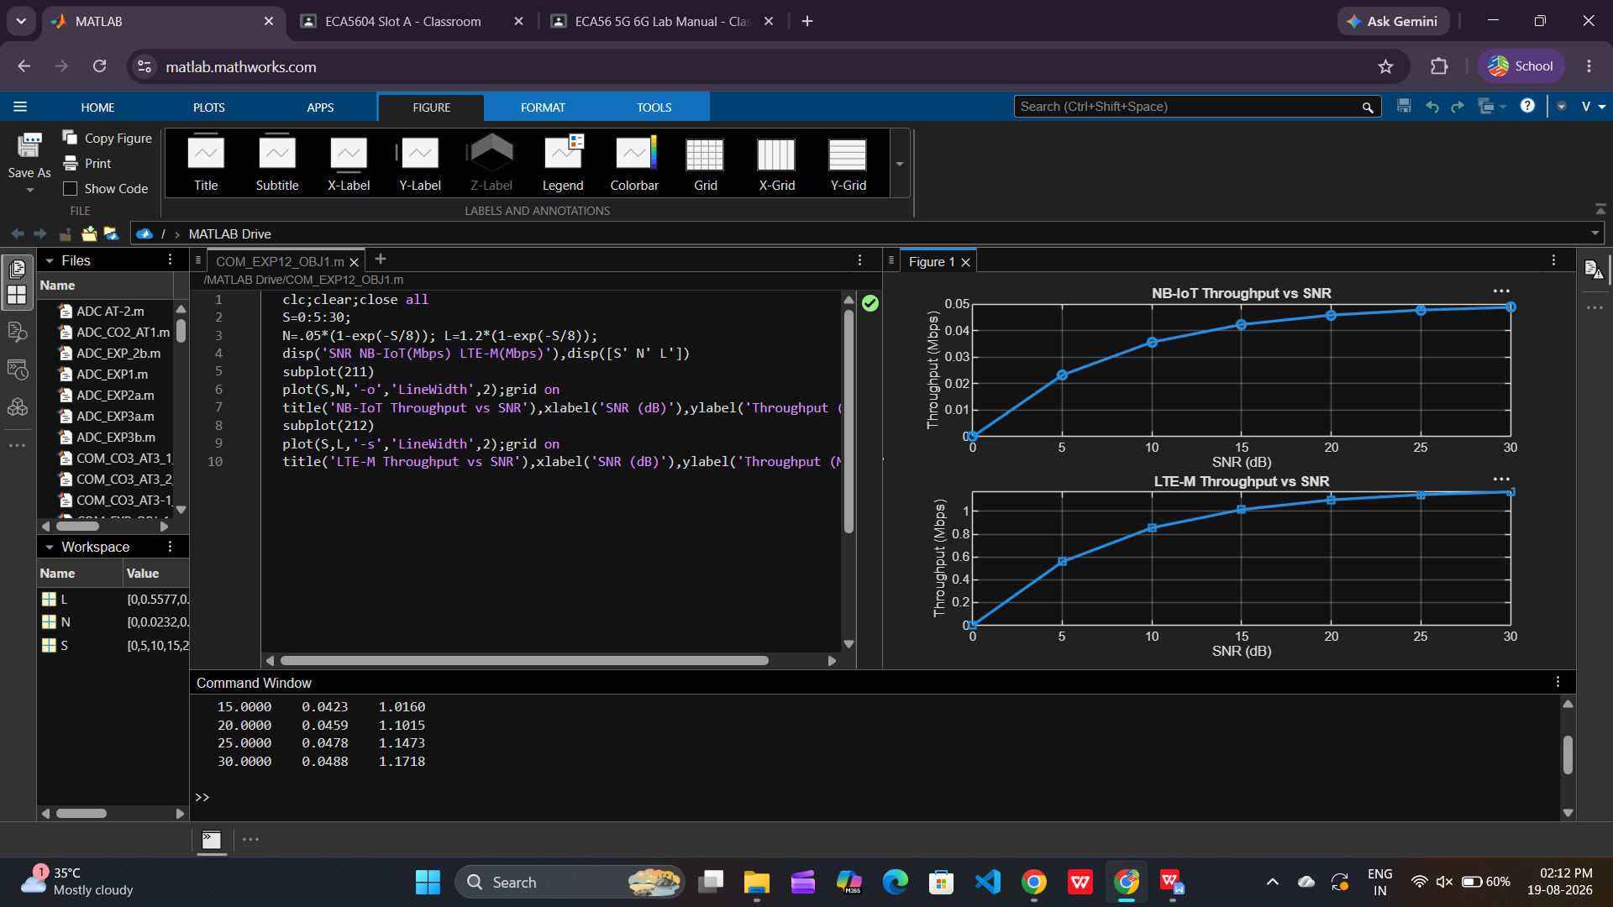

Objective 2: To analyze the Latency (ms) characteristics of NB-IoT and LTE-M and study their
impact on real-time communication.

Matlab Code:

clc;clear;close all
S=0:5:30;
N=[180 160 145 130 120 110 100];
L=[90 80 70 60 50 45 40];
disp('SNR NB-IoT Latency LTE-M Latency'),disp([S' N' L'])
subplot(211)
plot(S,N,'-o','LineWidth',2);grid on
title('NB-IoT Latency vs SNR'),xlabel('SNR (dB)'),ylabel('Latency (ms)')
subplot(212)
plot(S,L,'-s','LineWidth',2);grid on
title('LTE-M Latency vs SNR'),xlabel('SNR (dB)'),ylabel('Latency (ms)')

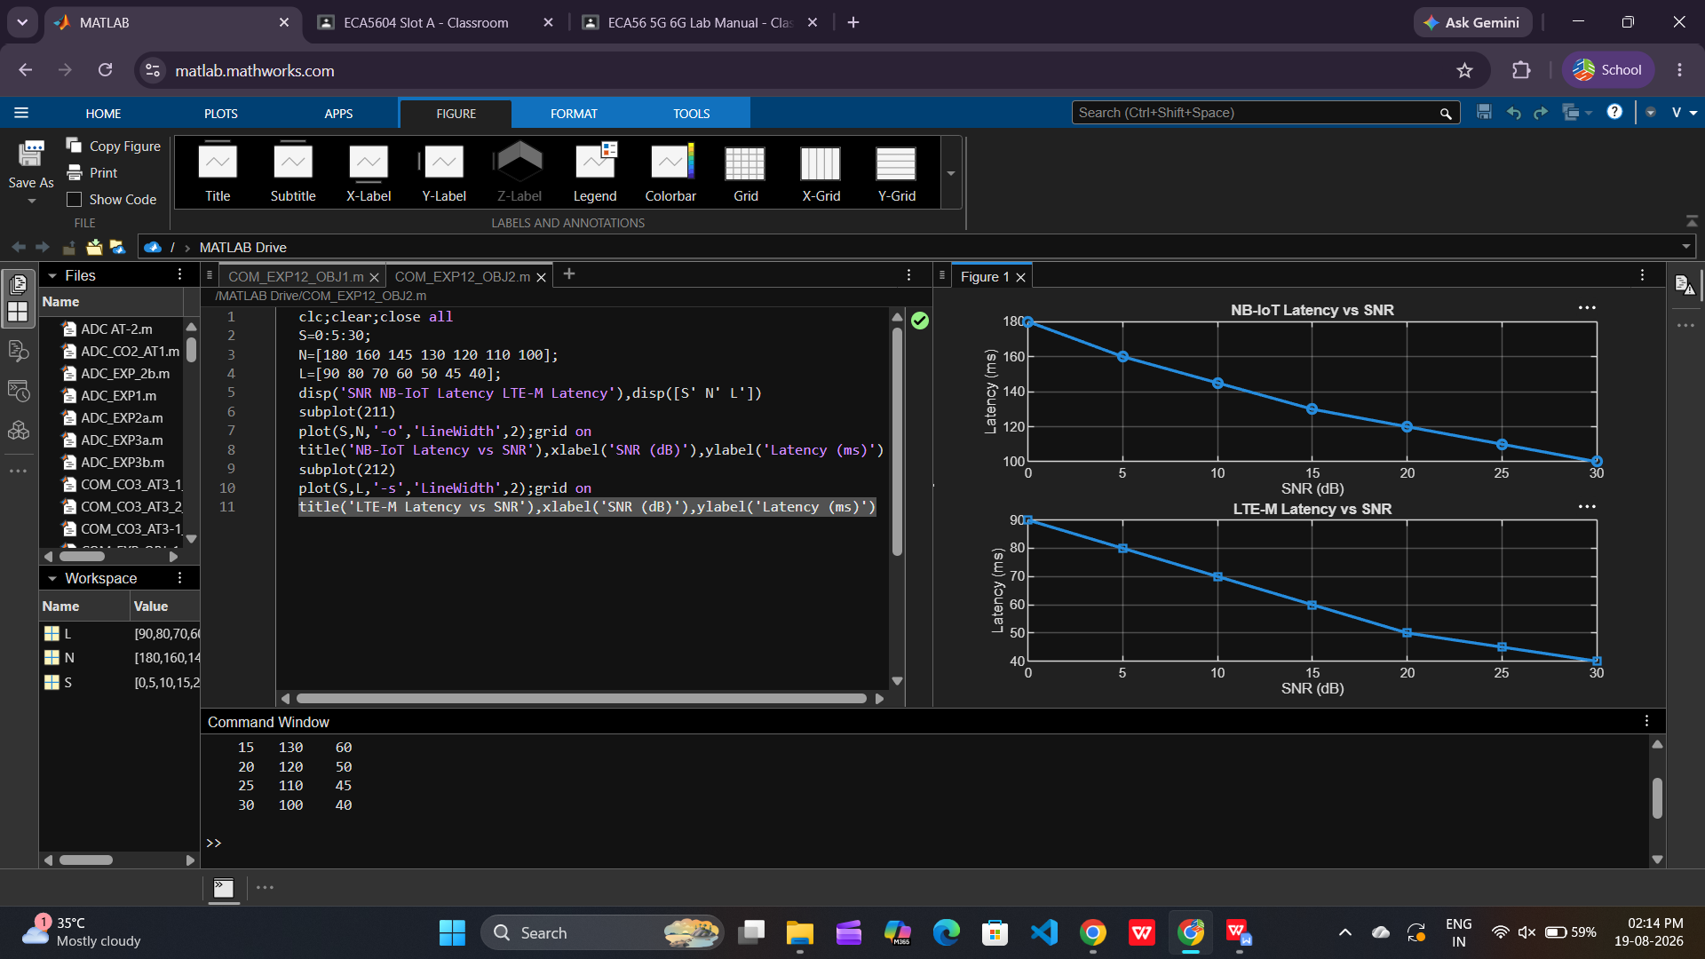

Objective 3: To measure and compare the Packet Delivery Ratio (%) of NB-IoT and LTE-M
systems for reliability assessment.

Matlab Code:

clc;clear;close all
S=0:5:30;
N=[82 86 89 92 95 97 99];
L=[88 91 94 96 98 99 100];
disp('SNR NB-IoT PDR LTE-M PDR'),disp([S' N' L'])
subplot(211)
plot(S,N,'-o','LineWidth',2);grid on
title('NB-IoT Packet Delivery Ratio vs SNR'),xlabel('SNR (dB)'),ylabel('PDR (%)')
subplot(212)
plot(S,L,'-s','LineWidth',2);grid on
title('LTE-M Packet Delivery Ratio vs SNR'),xlabel('SNR (dB)'),ylabel('PDR (%)')

